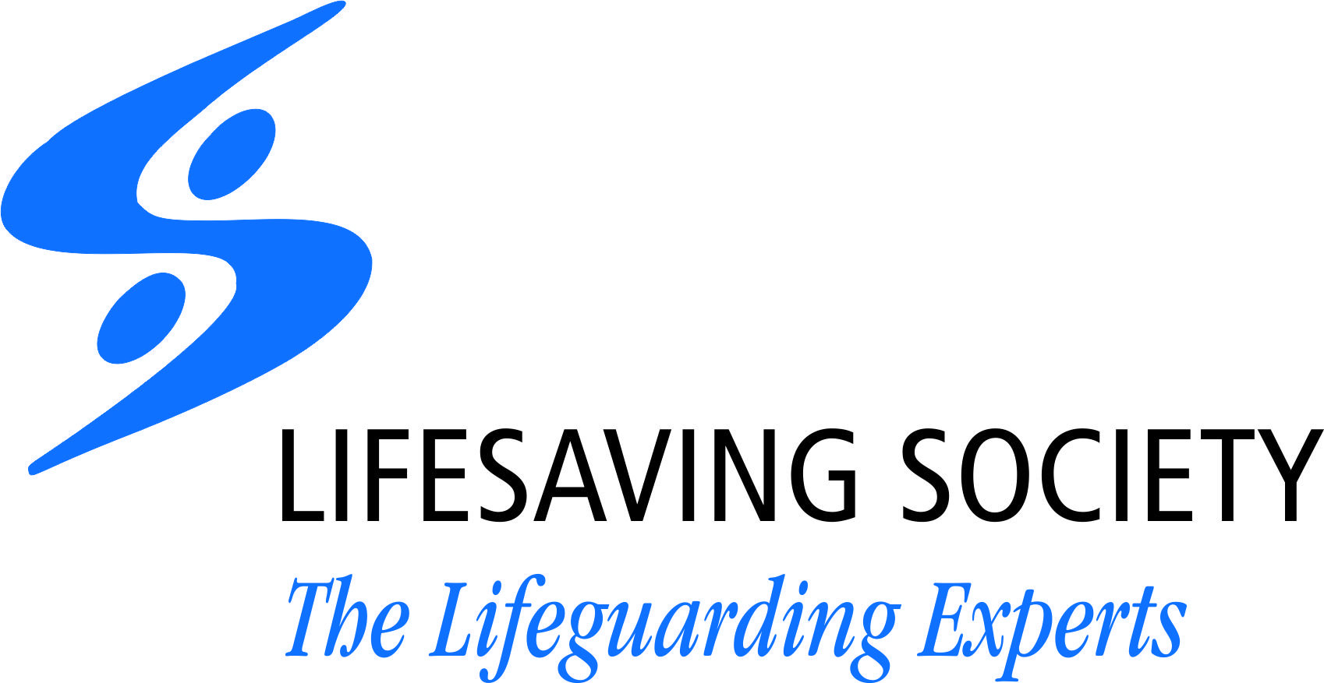
RESCUE AWARD OF MERIT NOMINATION
Rescue Award of Merit: presented by the Lifesaving Society to an individual in recognition of intervention in a water-related emergency or to a Lifesaving Society Award holder for intervention in either an aquatic or non-aquatic emergency.
Eligibility criteria: recognition of an emergency, willingness to intervene, evidence of judgment
INFORMATION ON RESCUER(S)
NAME:
ADDRESS:
CITY:
PROVINCE:
POSTAL CODE:
PHONE #:
EMAIL:
BIRTH DATE:
LIFESAVING SOCIETY AWARD HOLDER (Y/N): ID#:____________________
INFORMATION ON RESCUED INDIVIDUAL(S)
NAME:
ADDRESS:
CITY:
PROVINCE:
POSTAL CODE:
AGE:
INFORMATION ON ASSISTANTS (IF ANY)
NAME:
ADDRESS:
CITY:
PROVINCE:
POSTAL CODE:
AGE:
INFORMATION ON WITNESS (IF ANY)
NAME:
ADDRESS:
CITY:
PROVINCE:
POSTAL CODE:
AGE:
….../continued
LOCATION OF INCIDENT: ___________________________________________________________________
DATE AND TIME OF RESCUE: _______________________________________________________________
TYPE OF RESCUE (Aquatic or non-aquatic): ____________________________________________________
WEATHER CONDITIONS (Type and condition of water hazard (temperature, depth, wave size, wind, current, distance from shore, dock, etc.)
_________________________________________________________________________________________________________________________________________________________________________________________
COMPLETE DESCRIPTION OF THE RESCUE OPERATION (include specific techniques used and procedures followed; and degree of personal danger in which the rescuer and rescued were placed. Include any media clippings if possible. )
_____________________________________________________________________________________________________________________________________________________________________________________________________________________________________________________________________________________________________________________________________________________________________________________________________________________________________________________________________________________________________________________________________________________________________________________________________________________________________________________________________________________________________________________________________________________________________________________________________________________________________________________________________
POST-RESCUE TREATMENT OF THE VICTIM (ambulance, hospital [duration, treatment], etc.):
__________________________________________________________________________________________________________________________________________________________________________________________
Submit nominations to the Lifesaving Society:
• Email: experts@lifeguarding.com • Fax: 416-490-8766 • Mail: 400 Consumers Road, Toronto, ON M2J1P8
If possible, please attach signed statements from the rescuer, the rescued and any witnesses to the rescue.
_____________________________________ and / or _________________________________________
Signature of person submitting nomination Signature of guarantor of bona fides of rescuer
______________________________ _________________________________
Date Date

